Creation of Wordpress using docker-compose

Create a directory for your docker-compose file

# #mkdir worpress

# #cd worpress

Now make sure the server is uptodate , I’m using Ubuntu AMI

# #apt update -y

# #apt install docker-compose docker.io

check the version using

# #docker –version

# #docker-compose –version

Now write the docker-compose file

# #vim docker-compose.yml

version: "3"

services:

wordpress:

image: wordpress

ports:

- "8085:80"

depends_on:

- mysql

environment:

WORDPRESS_DB_HOST: mysql

WORDPRESS_DB_USER: root

WORDPRESS_DB_PASSWORD: "password"

WORDPRESS_DB_NAME: wordpress

mysql:

image: "mysql:5.7"

environment:

MYSQL_DATABASE: wordpress

MYSQL_ROOT_PASSWORD: "password"

volumes:

- ./mysql:/var/lib/mysql

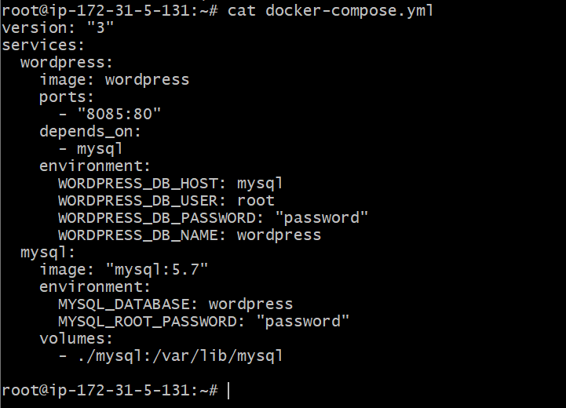

This is a YAML file used to set up two services, WordPress and MySQL, using Docker containers.

WordPress is a popular content management system (CMS) for creating websites, and MySQL is a database management system used to store WordPress data.

Here's what each section does:

* **version: "3"**: This indicates the version of the Docker Compose file format being used.
* **services:**: This section defines the services that will be created.
* **wordpress:**: This defines the WordPress service.
  + **image: wordpress**: This specifies the Docker image (a pre-packaged software) to use for the WordPress service.
  + **ports:**: This maps ports from the container to the host system, allowing access to the WordPress site via port 8085 on the host.
  + **depends_on:**: This specifies that the WordPress service depends on the MySQL service, meaning MySQL will be started first.
  + **environment:**: This sets environment variables for the WordPress service, including the database host, username, password, and database name.
* **mysql:**: This defines the MySQL service.
  + **image: "mysql:5.7"**: This specifies the Docker image to use for the MySQL service, version 5.7.
  + **environment:**: This sets environment variables for the MySQL service, including the database name and root user's password.
  + **volumes:**: This mounts a directory from the host system (**./mysql**) to a directory within the MySQL container, allowing data to persist between container restarts.

This will run the wordpress on our server on port 8085

Make sure to add 8085 on firewall/AWS security group

Now access it using <IP:8085>

